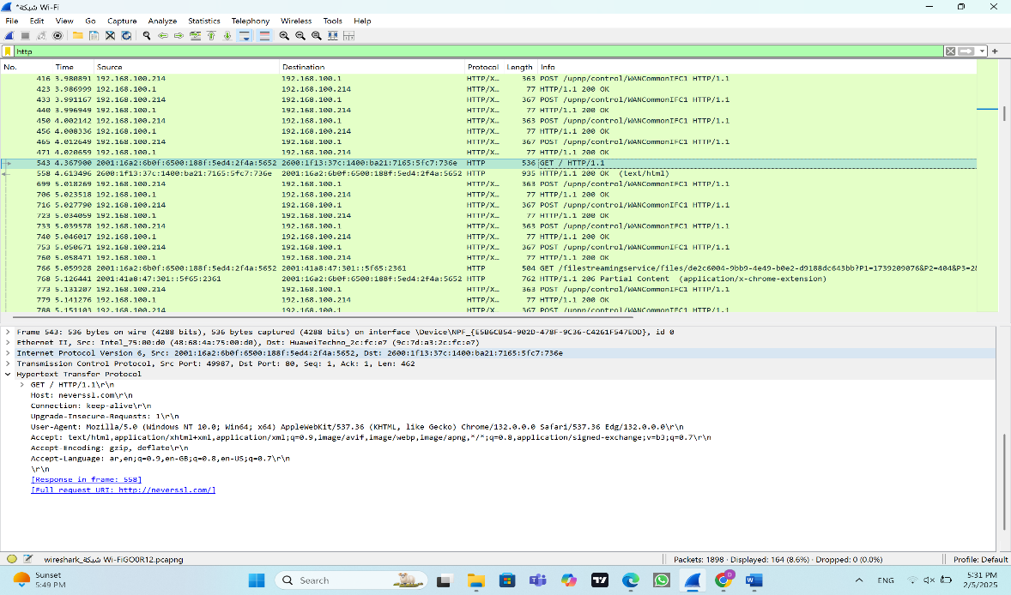HTTP :

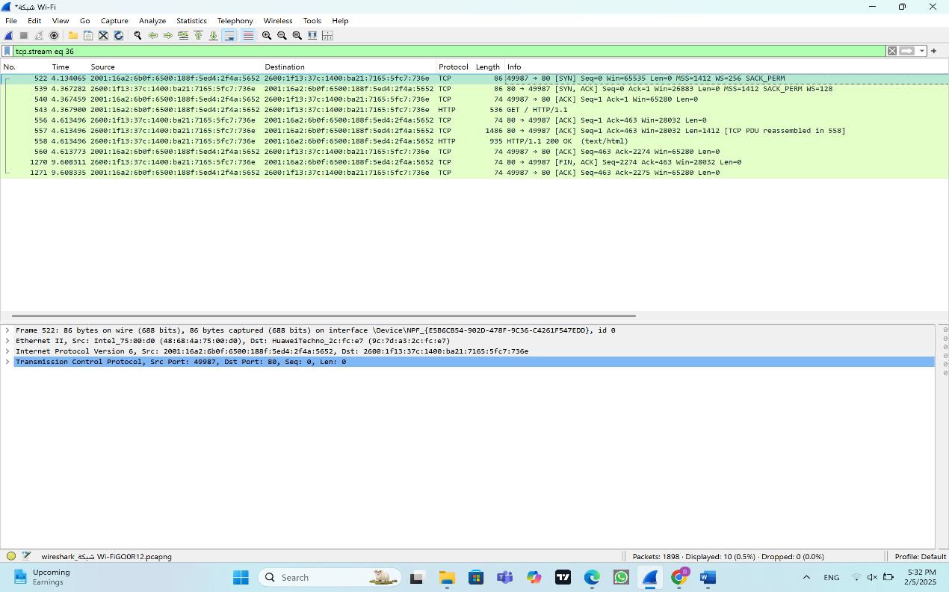TCP :

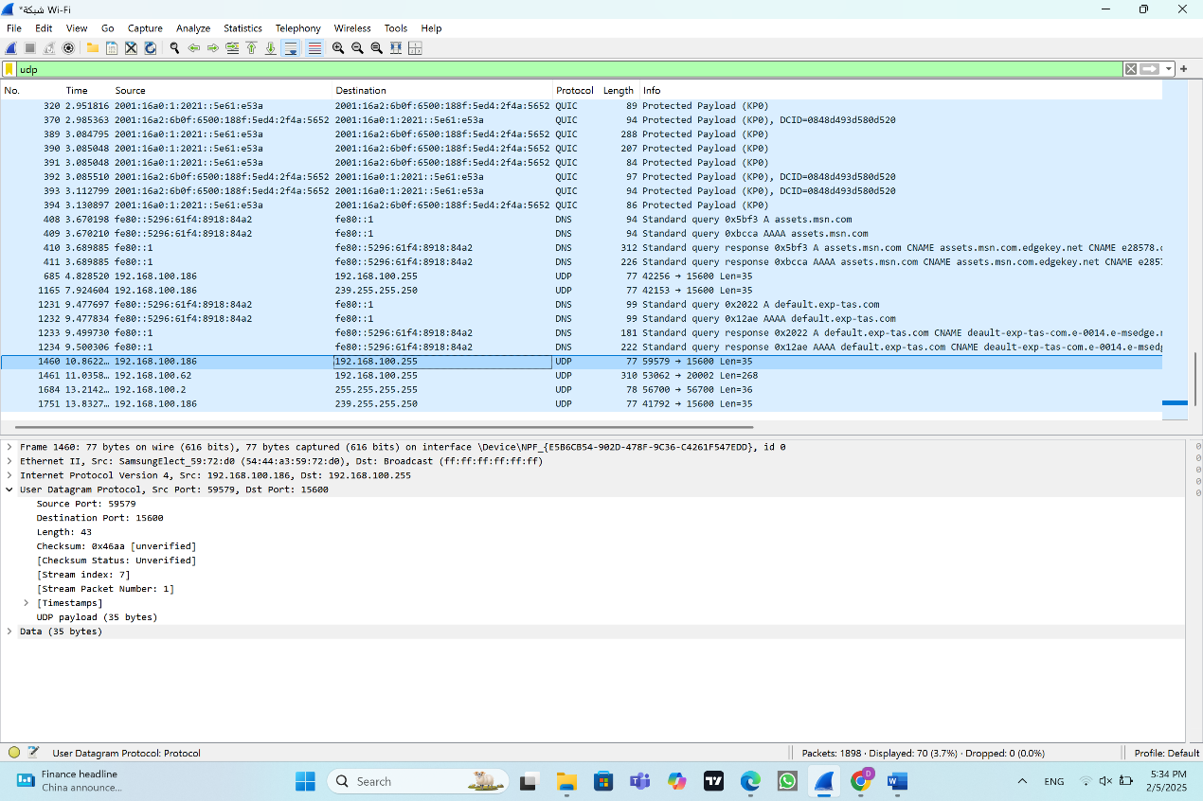

UDP:

|  |  |  |
| --- | --- | --- |
|  | TCP or UDP | Reasons |
| Reliability and Connection Establishment | TCP | TCP provides a more reliable connection than UDP because it establishes a connection using a three-way handshake, ensuring data integrity and ordered delivery. |
| Data Integrity and Ordering | TCP | TCP utilizes sequence numbers and acknowledgments to maintain data integrity and ensure correct ordering of transmitted data. |

|  |  |  |
| --- | --- | --- |
|  | TCP | UDP |
| Use cases | Email, Web browsing, File transfer | Streaming, online game, VoIP |
| Performance | Data integrity, Reliable, Bigger overhead | Faster, Smaller overhead, some data is missed |